Task 1: Install MySQL or PostgreSQL and create a database named 'music_streaming_app'.
Query / Answer:
CREATE DATABASE music_streaming_app;
Image / Screenshot:
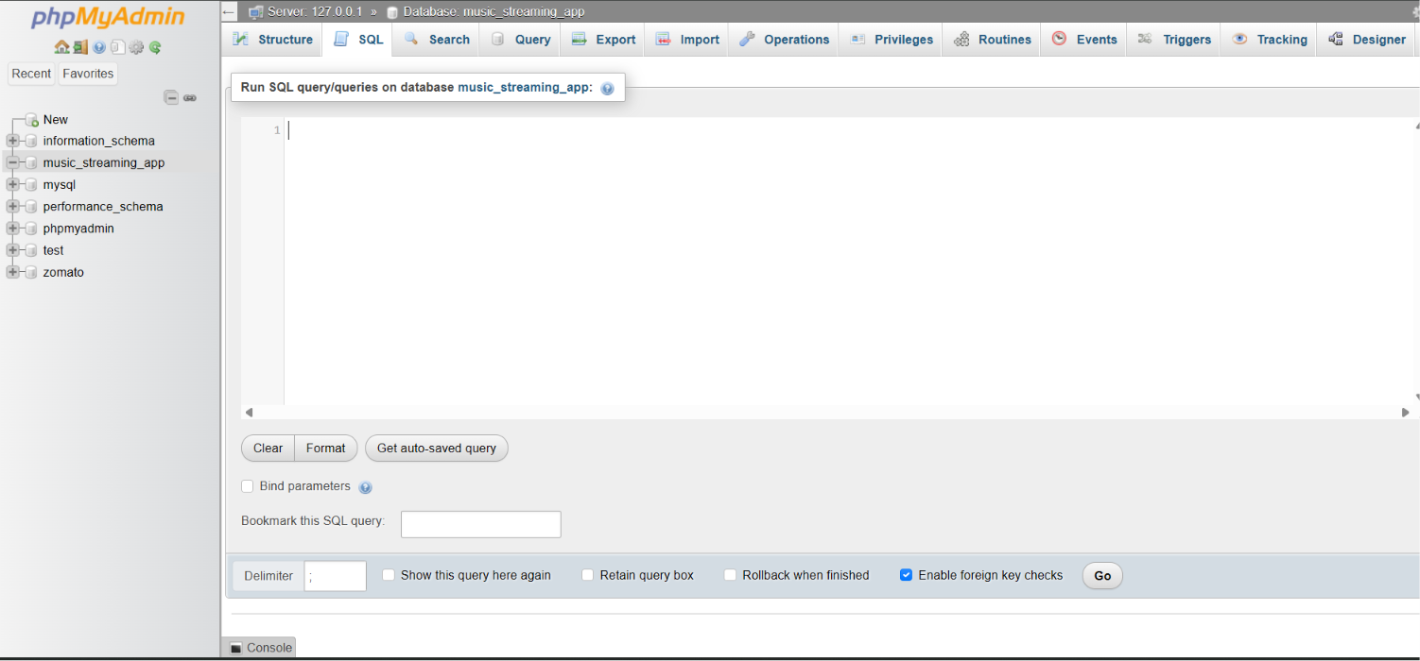

Task 2: Create a table named 'playlists' with columns: playlist_id, name, and created_by.
Query / Answer:
CREATE TABLE playlist(
playlist_id int NOT NUll,
playlist_name varchar(50) NOT NULL,
created_by varchar(50) NOT NULL

)

Image / Screenshot:
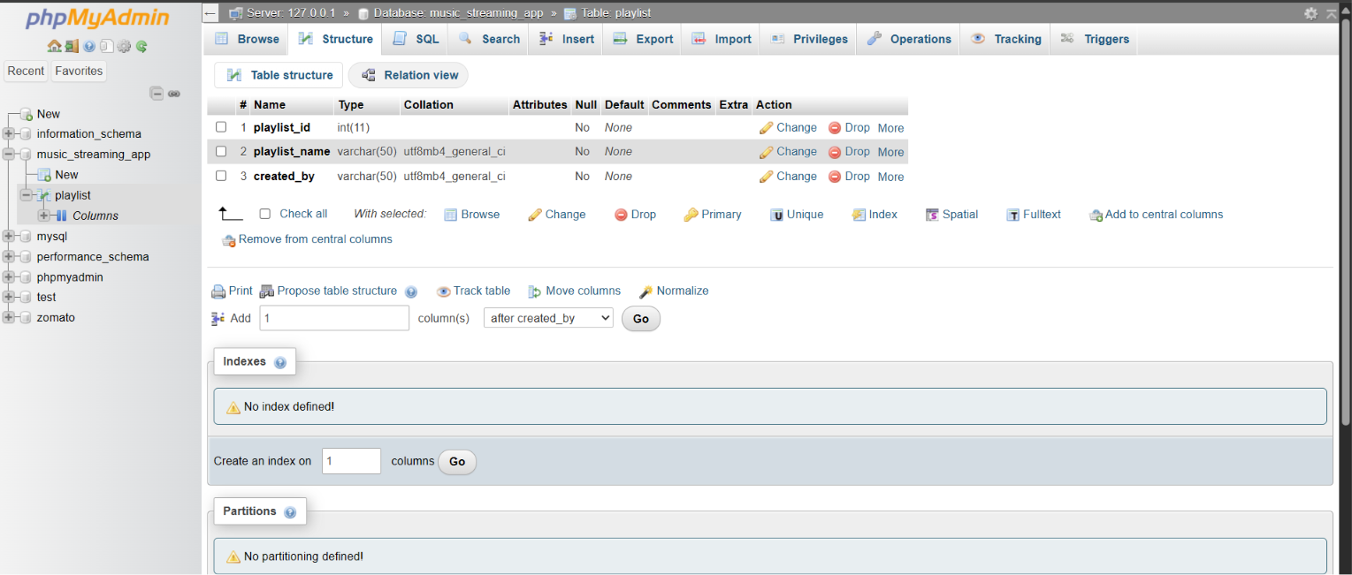

Task 3: Insert three sample rows into the playlists table representing Bollywood Hits, Chill Vibes, and Workout Mix.
Query / Answer:
INSERT INTO playlist(playlist_id , playlist_name , created_by) VALUES (1 , "bollywood hits" , "T-series");
INSERT INTO playlist(playlist_id , playlist_name , created_by) VALUES (2 , "Chill vides" , "Saregama");
INSERT INTO playlist(playlist_id , playlist_name , created_by) VALUES (3 , "Workout mix" , "DJ");

Image / Screenshot:
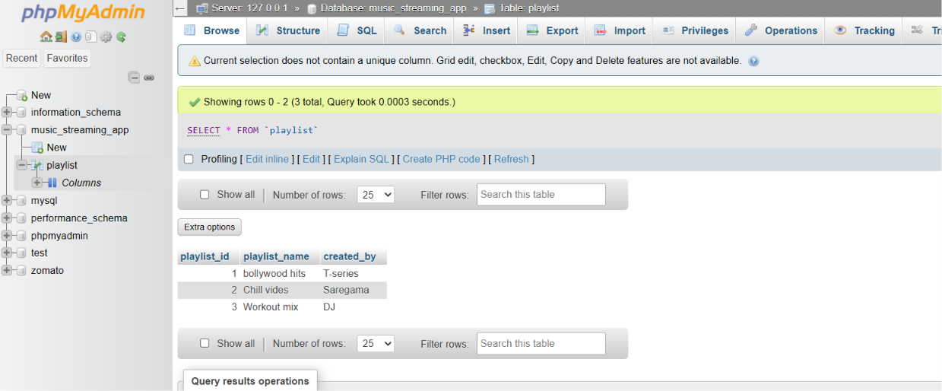

Task 4: Display all playlists created by the user 'Amit' using a SELECT query with a WHERE clause.
Query / Answer:
SELECT * FROM playlist WHERE created_by = "T-series";
Image / Screenshot:
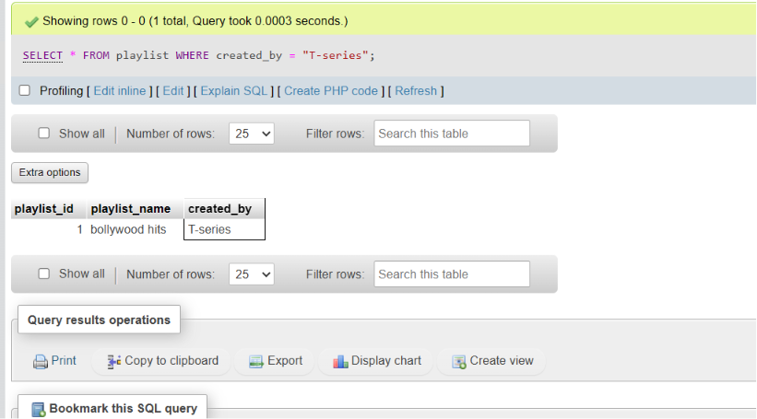

Task 5: Explain the difference between a table, row, and column using a food delivery app example (e.g., Zomato).
Query / Answer:
Table :- Is a collection of data represented in a rows and Column format .
Row :- A entry consisting multiple values of multiple topics
Column :- A column is a Feature or a category

Table:
A table is a collection of related data organized into rows and columns. In a food delivery app like Zomato, a table named Restaurants can store information about all restaurants available on the platform.
Column:
A column represents a specific attribute or category of data in a table. For example, the Restaurants table may have columns such as Restaurant_ID, Restaurant_Name, City, and Rating.
Row:
A row represents a single record in a table. Each row contains information about one restaurant. For example, a row might store details of a restaurant called "Spice Villa" located in Surat with a rating of 4.5.
Image / Screenshot:

